**Assignment 19.1:**

Using spark-sql, Find:

1. What is the total number of gold medal winners every year?

2. How many silver medals have been won by USA in each sport?

Start spark-shell:

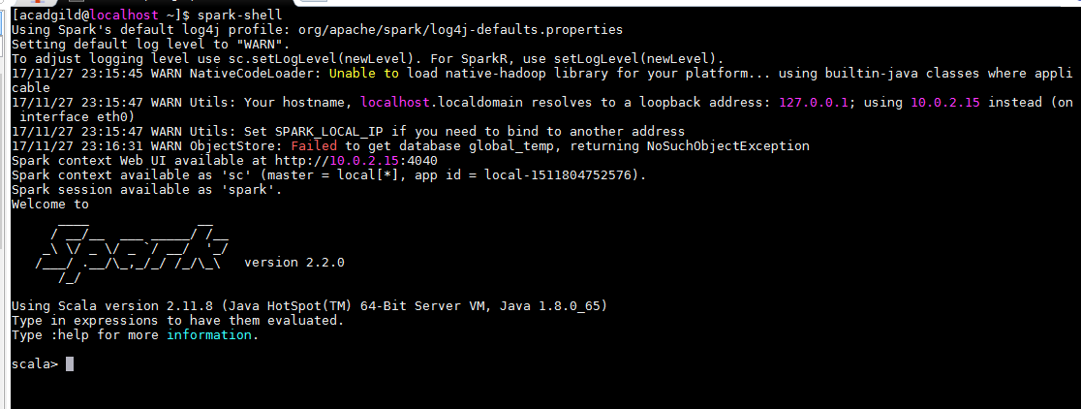

Create RDD with the imported file data.

Load the table data into dataframe.

Register the data frame with temporary table.

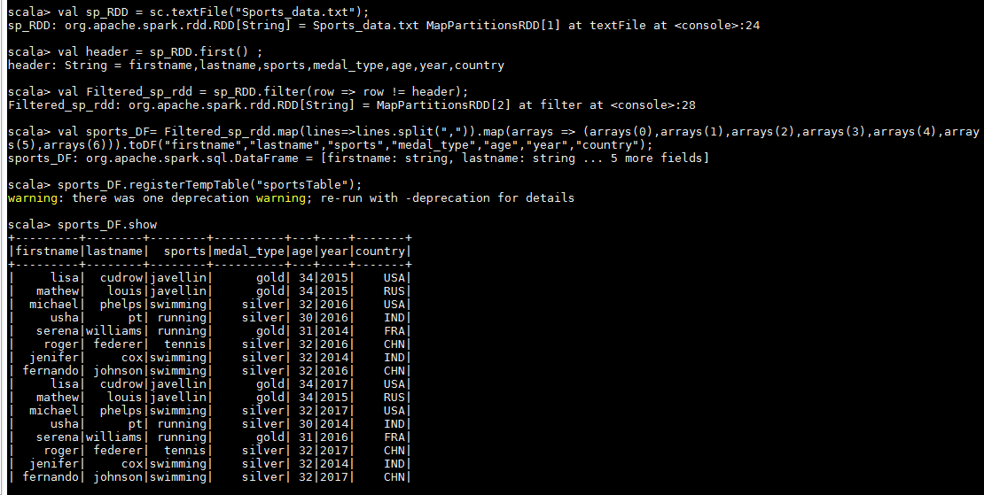

1. What is the total number of gold medal winners every year?

val goldmedal_winner_DF = spark.sql("SELECT year, count(*) FROM sportsTable where medal_type='gold' group by year order by year");

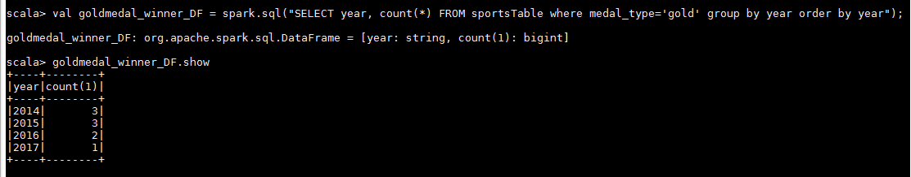

1. How many silver medals have been won by USA in each sport?

val silver_medal_DF = spark.sql("SELECT country, sports, count(*) FROM sportsTable where country='USA' and medal_type='silver' group by country,sports");

